**Part 1: SDG Selection and Problem Definition**

1. **Choose an SDG**

SDG 7: Affordable and Clean Energy.

1. **Define a Specific Problem:** **Example Problem**

### ****Problem Definition:****

The inefficient distribution and installation of solar panels in rural areas is hindering access to clean and affordable energy. Despite the availability of solar energy resources, many rural communities remain underserved due to a lack of data-driven insights into where and how resources should be allocated. This project aims to address this issue by analyzing the distribution patterns, efficiency, and population coverage of solar panel installations, providing actionable insights to optimize resource allocation and improve energy access in rural regions.

**Part 2: Database Design**

**ERD**

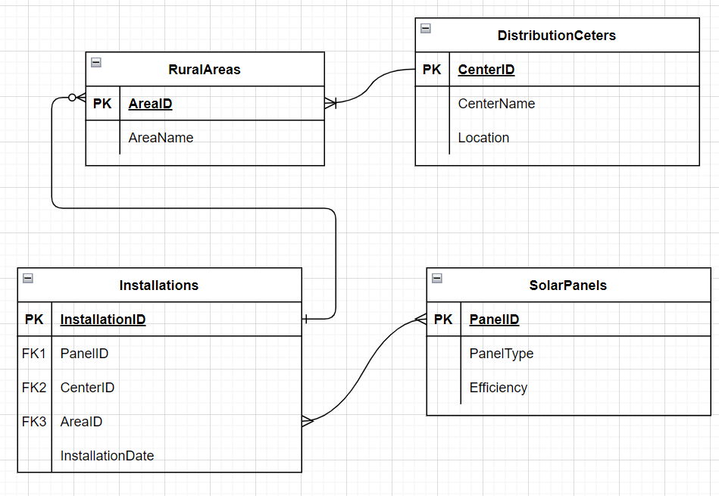

**CREATE DB WITH TABLES &SAMPLE DATA**

mysql> create database clean_energy;

Query OK, 1 row affected (1.56 sec)

mysql> use clean_energy;

Database changed

mysql> CREATE TABLE SolarPanels (

-> PanelID INT PRIMARY KEY,

-> PanelType VARCHAR(50),

-> Efficiency DECIMAL(5,2)

-> );

Query OK, 0 rows affected (4.38 sec)

mysql>

mysql> CREATE TABLE DistributionCenters (

-> CenterID INT PRIMARY KEY,

-> CenterName VARCHAR(100),

-> Location VARCHAR(100)

-> );

Query OK, 0 rows affected (0.81 sec)

mysql>

mysql> CREATE TABLE RuralAreas (

-> AreaID INT PRIMARY KEY,

-> AreaName VARCHAR(100),

-> Population INT

-> );

Query OK, 0 rows affected (0.80 sec)

mysql>

mysql> CREATE TABLE Installations (

-> InstallationID INT PRIMARY KEY,

-> PanelID INT,

-> CenterID INT,

-> AreaID INT,

-> InstallationDate DATE,

-> FOREIGN KEY (PanelID) REFERENCES SolarPanels(PanelID),

-> FOREIGN KEY (CenterID) REFERENCES DistributionCenters(CenterID),

-> FOREIGN KEY (AreaID) REFERENCES RuralAreas(AreaID)

-> );

Query OK, 0 rows affected (1.23 sec)

mysql> INSERT INTO SolarPanels (PanelID, PanelType, Efficiency) VALUES (1, 'Mono-crystalline', 19.5);

Query OK, 1 row affected (0.66 sec)

mysql> INSERT INTO DistributionCenters (CenterID, CenterName, Location) VALUES (1, 'GreenEnergy Hub', 'CityA');

Query OK, 1 row affected (0.09 sec)

mysql> INSERT INTO RuralAreas (AreaID, AreaName, Population) VALUES (1, 'VillageX', 5000);

Query OK, 1 row affected (0.05 sec)

mysql> INSERT INTO Installations (InstallationID, PanelID, CenterID, AreaID, InstallationDate) VALUES (1, 1, 1, 1, '2024-08-01');

Query OK, 1 row affected (0.62 sec)

**PART 3 :SQL Programming**

**Data Retrival**

SELECT * FROM Installations WHERE InstallationDate >= '2024-01-01';

**Data Analysis**

SELECT AreaName, COUNT(InstallationID) AS NumberOfInstallations

FROM Installations

JOIN RuralAreas ON Installations.AreaID = RuralAreas.AreaID

GROUP BY AreaName;

**PART 4: Data Analysis Using Excel**

**PART 5: Intergration and Testing**

**Steps to Import SQL Data into Excel:**

1. **Prepare Database:** Ensure your SQL database is accessible with correct credentials.
2. **Install ODBC Driver:** Download and install the necessary ODBC driver for your database (e.g., MySQL, PostgreSQL).
3. **Connect Excel to Database:**
   * Open Excel, go to the Data tab, select Get Data, and choose From Database.
   * Enter server, database, and login credentials.
   * Select and load the desired table or view.
4. **Analyze Data:** Use Excel tools like PivotTables and charts to analyze the imported data. Create visualizations and dashboards as needed.